**USER MANUAL FOR AUTOMATED LOCKER BANK IN ALDEN HIGH SCHOOL**

**Prepared By:**

**Tijmen Van Der Beek, Siquan Wang, Miren Patel, Xiaoang Zhang, Dazhou Liu**

*School of Engineering and Applied Sciences*

*University at Buffalo, The State University of New York*

*Spring 2021*

**Contents**

**1 Introduction** **2**

**2 Locker Usage** **2**

**2.1 Locker Activation 2**

**2.2 Unlocking 2**

**2.3 Locking 2**

**2.4 Clearing Student Tags 3**

**2.5 Registering Student Tags 3**

**2.6 Initializing Locker 3**

**2.7 Resetting Locker Tags 3**

**3 LED Status** **4**

**4 RFID Tags** **5**

**5 Speaker Sounds** **5**

**6 Mechanical Override** **5**

**7 Power Source** **6**

**8 Troubleshootings** **6**

**9 Safety Information** **6**

# 1 Introduction

Based on client feedback, the locker system is designed to reduce frequent locker jams imposed by the current locker in Alden High School. In addition, features aiming to allow mass production of this locker system are incorporated. By using designated tags for the locker, users have an option for operating their locker with simplicity.

To facilitate the user to transit to this new locker system, this user manual includes descriptions of the electronic components, procedures of using the locker system and troubleshootings for possible failures. Photos of system components are also included to make this user manual intuitive.

# 2 Locker Usage

## 2.1 Locker Activation

Pressing the button on the front panel of the locker door activates the locker system. A LED enclosed inside the locker door then becomes red to indicate that the locker is ready to read tags but is locked. A speaker also produces sound to indicate this status. If the locker is idle for 30 seconds it will turn off automatically.

## 2.2 Unlocking

To unlock, an authorized RFID tag must be scanned on the front panel. They are master and user tags. When a master or an authorized user tag is detected, the locker door unlocks. The LED’s color turns to green and the speaker produces a sound. At this point, the user needs to push the locker door. Then the locker door pops out automatically, and the user gains access to their stuff in the locker.

## 2.3 Locking

If no action is taken by the user after 10 seconds upon unlocking, the solenoid will automatically lock. Then the user needs to lock the locker door again by pressing it back to the initial position. You can also press the button again to lock the locker earlier.

## 2.4 Clearing Student Tags

To clear all the student tags just scan the clear tag, the LED will blink pink and all student tags will be removed.

## 2.5 Registering Student Tags

To register a student tag scan the register tag. When the LED turns blue scan the student tag you want to register. If it blinks blue it has successfully registered if red then there was an issue.

## 2.6 Initializing Locker

When the locker is first turned on or reset it will start up in initialization mode. In this mode the led starts white and is trying to register the faculty tags. You start by choosing the master tag for the locker. Next it will turn Blue for the register tag. Next pink for the clear tag. Once all faculty tags are registered the locker will start up normally.

## 2.7 Resetting Locker Tags

If you are missing one of the faculty tags for your locker you will have to reset the locker to put the locker back in initialization mode. To reset the locker press the button (lightly) on the back of the case with a pencil. The led will blink purple twice and turn off when the button is pressed it will be in Initialization Mode.

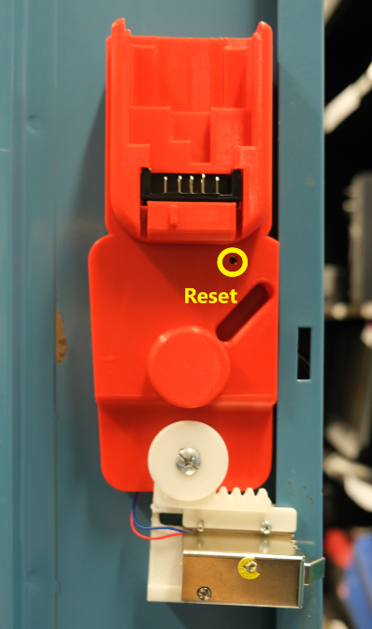

# 3 LED Status

There are two LEDs on the front panel.

* The left LED (right above the push button) indicates the status of the locker.

|  |  |
| --- | --- |
| **LED Colors** | **Locker Status** |
| Off | Initial Status |
| Red | Push button pressed, circuit turned on and ready to read the tags. |
| Green | Unlocked |
| Blue | Register mode or Register tag registration mode (after master tag reg) |
| Yellow | Processing |
| Pink | Clear tag registration mode |
| White | Master tag registration mode |
| Blinking RED | Wrong tag detected or Unsuccessful register |
| Blinking RED and Color of Tag Type | Faculty tag already registered |
| Blinking Green | Correct tag unlocking |
| Blinking Blue Twice | Successful tag register |
| Blinking Blue Three Times | Already registered |
| Blinking Pink | Clearing all tags |
| Blinking Purple and Turns Off | Locker reset |

* The right LED indicates the voltage level of the DeWalt battery.

|  |  |
| --- | --- |
| **LED Colors** | **Battery Status** |
| GREEN | Battery level sufficient (battery voltage greater than 10V) |
| RED | Battery is low (battery voltage less than 8V but greater than 7V) The battery needs to be charged. |
| Blinking Red | Battery is low (battery voltage less than 7 V) At this point, the locker will turn off after blinking red. |
| Off | Off |

# 4 RFID Tags

There are four types of tags: master, register, clear and user tag.

# 5 Speaker Sounds

A speaker is embedded for users with hearing impairment. There are three types of speaker sound.

* Sound when locker initialized
* Sound when unlocked
* Sound when error occured

# 6 Mechanical Override

Mechanical override is a solution to unlock the door for emergency situations (power failure or lost tags). The core components are two gears that are able to slide the solenoid horizontally.

A key is used to unlock externally, and the position of inserting the key is a keyhole located below the red push button on the front panel. When unlocking by mechanical override, the user first must insert the key and turn it clockwise. Upon successful unlocking, the user must turn the key counterclockwise to the initial position so that the locker is locked again.

# 7 Power Source

The power source of each locker is a DeWalt 12V battery, and it does not utilize wall power. When exhausted, the battery inside the locker door needs to be detached and charged in the DeWalt Battery Charger.

By fully charging the DeWalt 12V battery, the locker circuits can be supported for approximately 3 months, assuming each user unlocks five times a day.

In case of power failure of the DeWalt 12V battery, mechanical override is required to unlock the locker for further actions.

# 8 Troubleshootings

* If the locker turns on but doesn't seem to work properly try recharging the battery.
* If the solenoid stops working when the locker is unlocked try recharging the battery.
* If the locker is blinking red or not turning on when pressing the power button try recharging the battery.
* If the locker is not turning on try pushing in the dewalt battery completely.
* If the solenoid latch is stuck in unlock position, easily tab the solenoid case to reset back to lock position.

# 9 Safety Information

Most of the wires and electronic components are enclosed inside cases. But one portion of a wire that connects to the solenoid may be exposed. Be careful to avoid contacting that wire.